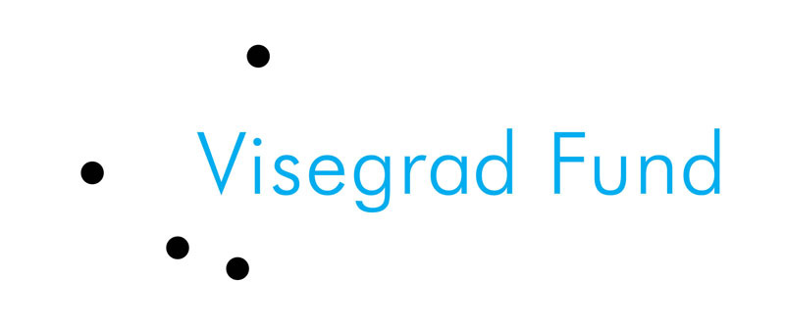

A body in Central- and Eastern European iconography
(15th–18th century) within the historical context

the International Visegrad Fund
Small Grants Programme
project no. 11510312

Call for Applications

The Silesian University in Opava, Czech Republic in cooperation with the Centre for Medieval Studies, Prague, Czech Republic, University of Szeged, Hungary, Poznan University of Medical Sciences, Poland and University of Economics, Bratislava, Slovakia, organises a workshop in Opava, Czecz Republic.

Participation:

The workshop is a part of a project “A body in Central- and Eastern European iconography (15th-18th century) within the historical context” and is eligible for scholars from the Czech Republic, Slovakia, Hungary, Poland, students from these countries, school teachers from the Czech Republic (because of the place, where workshop will take place), as well as cultural institution employees.

Aim:

Hitherto research on the history of a body concern mostly situation in Western Europe. Historians do not know much about Central- and Eastern European sources about this matter. French research in this issue is a very interesting methodological basis, but do not allows to acknowledge sources from other parts of Europe. A main goal of this project is to investigate a history of a body in a Central- and Eastern European iconography from 15th till 18th century considering already known methodology of research, but on a basis of historical sources, which have not been analysed before from this perspective. Members of the research team are scholars from Czech Republic, Hungary, Poland, and Slovakia. We would like to deliberate how a human body is depicted in Central- and Eastern European iconography and investigate what influence on those presentations had historical context: Reformation, political systems of particular states, social structure and status.

Results:

Among results of research made by members of a research team is going to be a series of articles prepared jointly. We also plan to organise a short (lasting two days) workshop, so that all researchers could meet together (during the first day) and could work with invited students (during the second day).

Workshop:

Researchers and students will meet in Opava (Czech Republic). During the first day of a workshop all stages of the project are going to be summarized (we plan to have constant contact via e-mails during the whole project), conclusions and plans for future cooperation are going to be gathered as we assume that results of the project are going to be a basis for the future, more detailed, research on the history of a body. We want to invite students of History, Anthropology and History of Art from Hungary, Poland, Slovakia, and Czech Republic interested in the subject. Students (one from each country) are going to have opportunity to meet with members of research group and to work with them on a short description and a plan of their own future research (for example MA thesis).

We would like to encourage all students interested in above mentioned field of research to send their application form and join the project.

Contact: bodyineuropeanhistory@gmail.com

Deadline for application: September 1, 2015, 12.00 am CET
Place: Silesian University in Opava, Czech Republic
Date: September 18–19, 2015
Fees: there is no fee. We are not able to fund any scholarship for students, although we cover travel and accommodation costs for participants as well as provide coffee brakes and lunches for workshop.

We will inform all applicants via e-mail about our decision before September 6, 2015.

A body in Central- and Eastern European iconography
(15th–18th century) within the historical context

the International Visegrad Fund
Small Grants Programme
project no. 11510312

STUDENT’S APPLICATION FORM

Applicant

Name:
Address:
E-mail address:

Languages and learning

Native language | …………………………………
Languages
- English | - intermediate | - advanced | - proficient
- Other  ………………………….. | - intermediate | - advanced | - proficient
Education:
University
Faculty
Specialization
Year
Main courses (with grades):
I
II
III
IV
Other skills and important information

Student’s project

Subject:
Tutor:
Description (max. 900 characters):

The application form should be submitted via e-mail: bodyineuropeanhistory@gmail.com

Please, send it as a .pdf file.

Deadline: September 1, 2015, 12.00 am CET.

